**SCHOOL MANAGEMENT SYSTEM**

**ZERO LEVEL DFD**

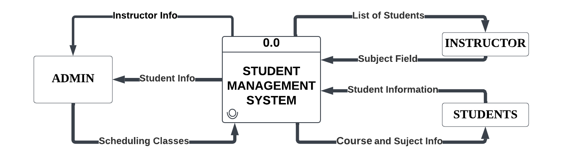

**SCHOOL MANAGEMENT SYSTEM**

**FIRST LEVEL DFD**

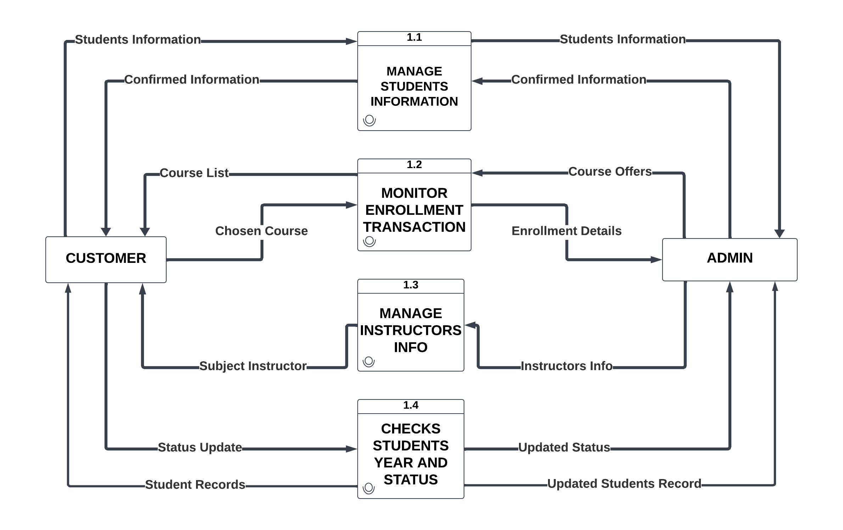

**SCHOOL MANAGEMENT SYSTEM**

**SECOND LEVEL DFD**

